What animal am I?
Give each student an animal card.
The student reads out the clues.
Other students try to guess what animal they are describing.
If you can guess after the first clue, you get five points.
After the second clue, four points etc.

20 Questions
Give each student an animal card.
Other students ask questions to try and figure out what animal is on the card.
I.e.: What colour is the animal? This animal has grey fur.
Or: Is the animal grey? No.
BUT the class only has 20 questions to figure it out!

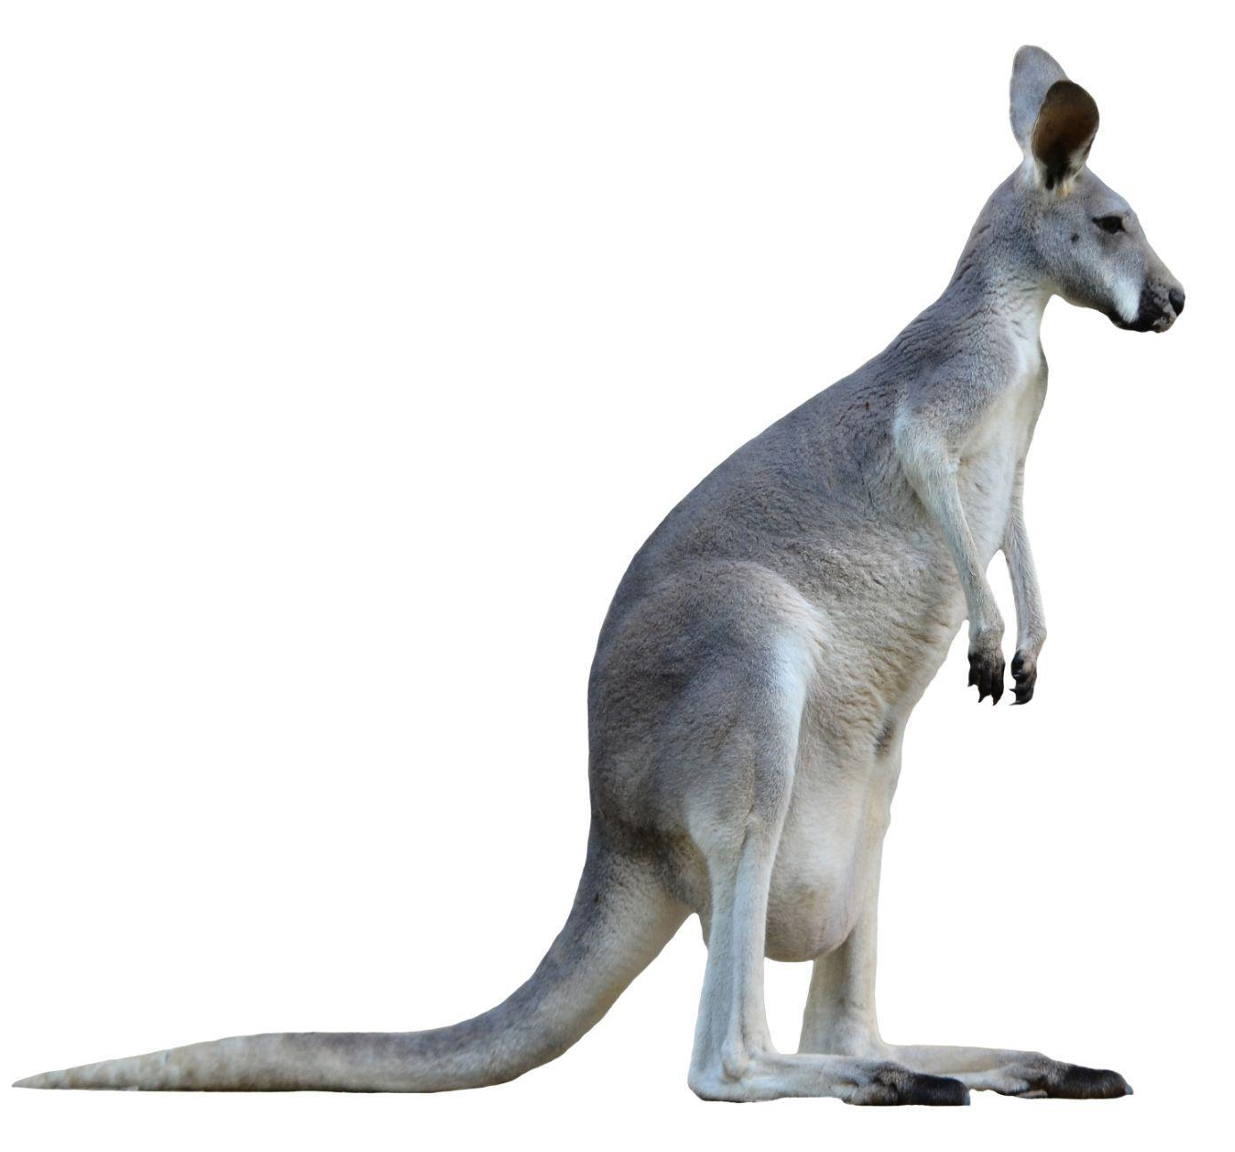
What animal am I?
5. I have fur.
4. I have big ears.
3. I eat grass.
2. I like to jump high.
1. I am a … kangaroo!

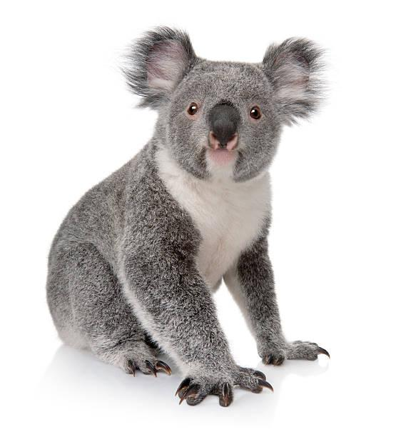
What animal am I?
5. I have fur.
4. I have big ears.
3. I eat leaves.
2. I like to sleep.
1. I am a … koala!
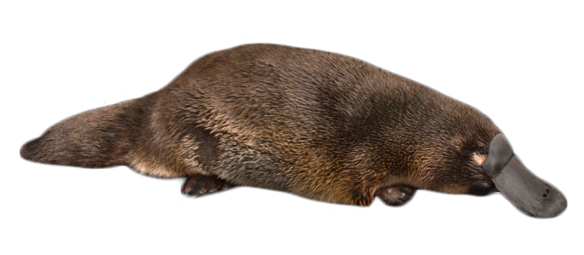
What animal am I?
5. I have fur.
4. I don’t have ears.
3. I eat insects.
2. I like to swim in the creek.
1. I am a … platypus!

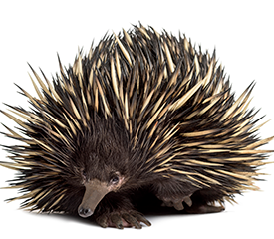
What animal am I?
5. I don’t have fur.
4. I dig in the dirt.
3. I like to eat insects.
2. I am very spiky.
1. I am an … echidna!

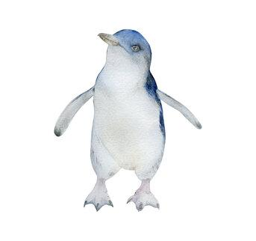
What animal am I?
5. I have feathers.
4. I am very small.
3. I am a good swimmer.
2. I live in St Kilda and on Phillip Island.
1. I am a … little penguin!

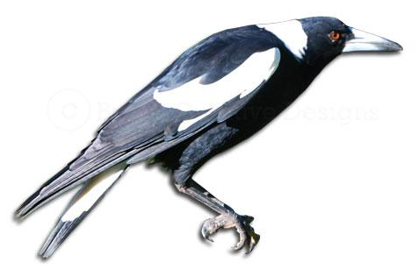
What animal am I?
5. I have feathers.
4. I like to eat worms.
3. I like to sing.
2. I like to swoop people riding their bikes.
1. I am a … magpie!
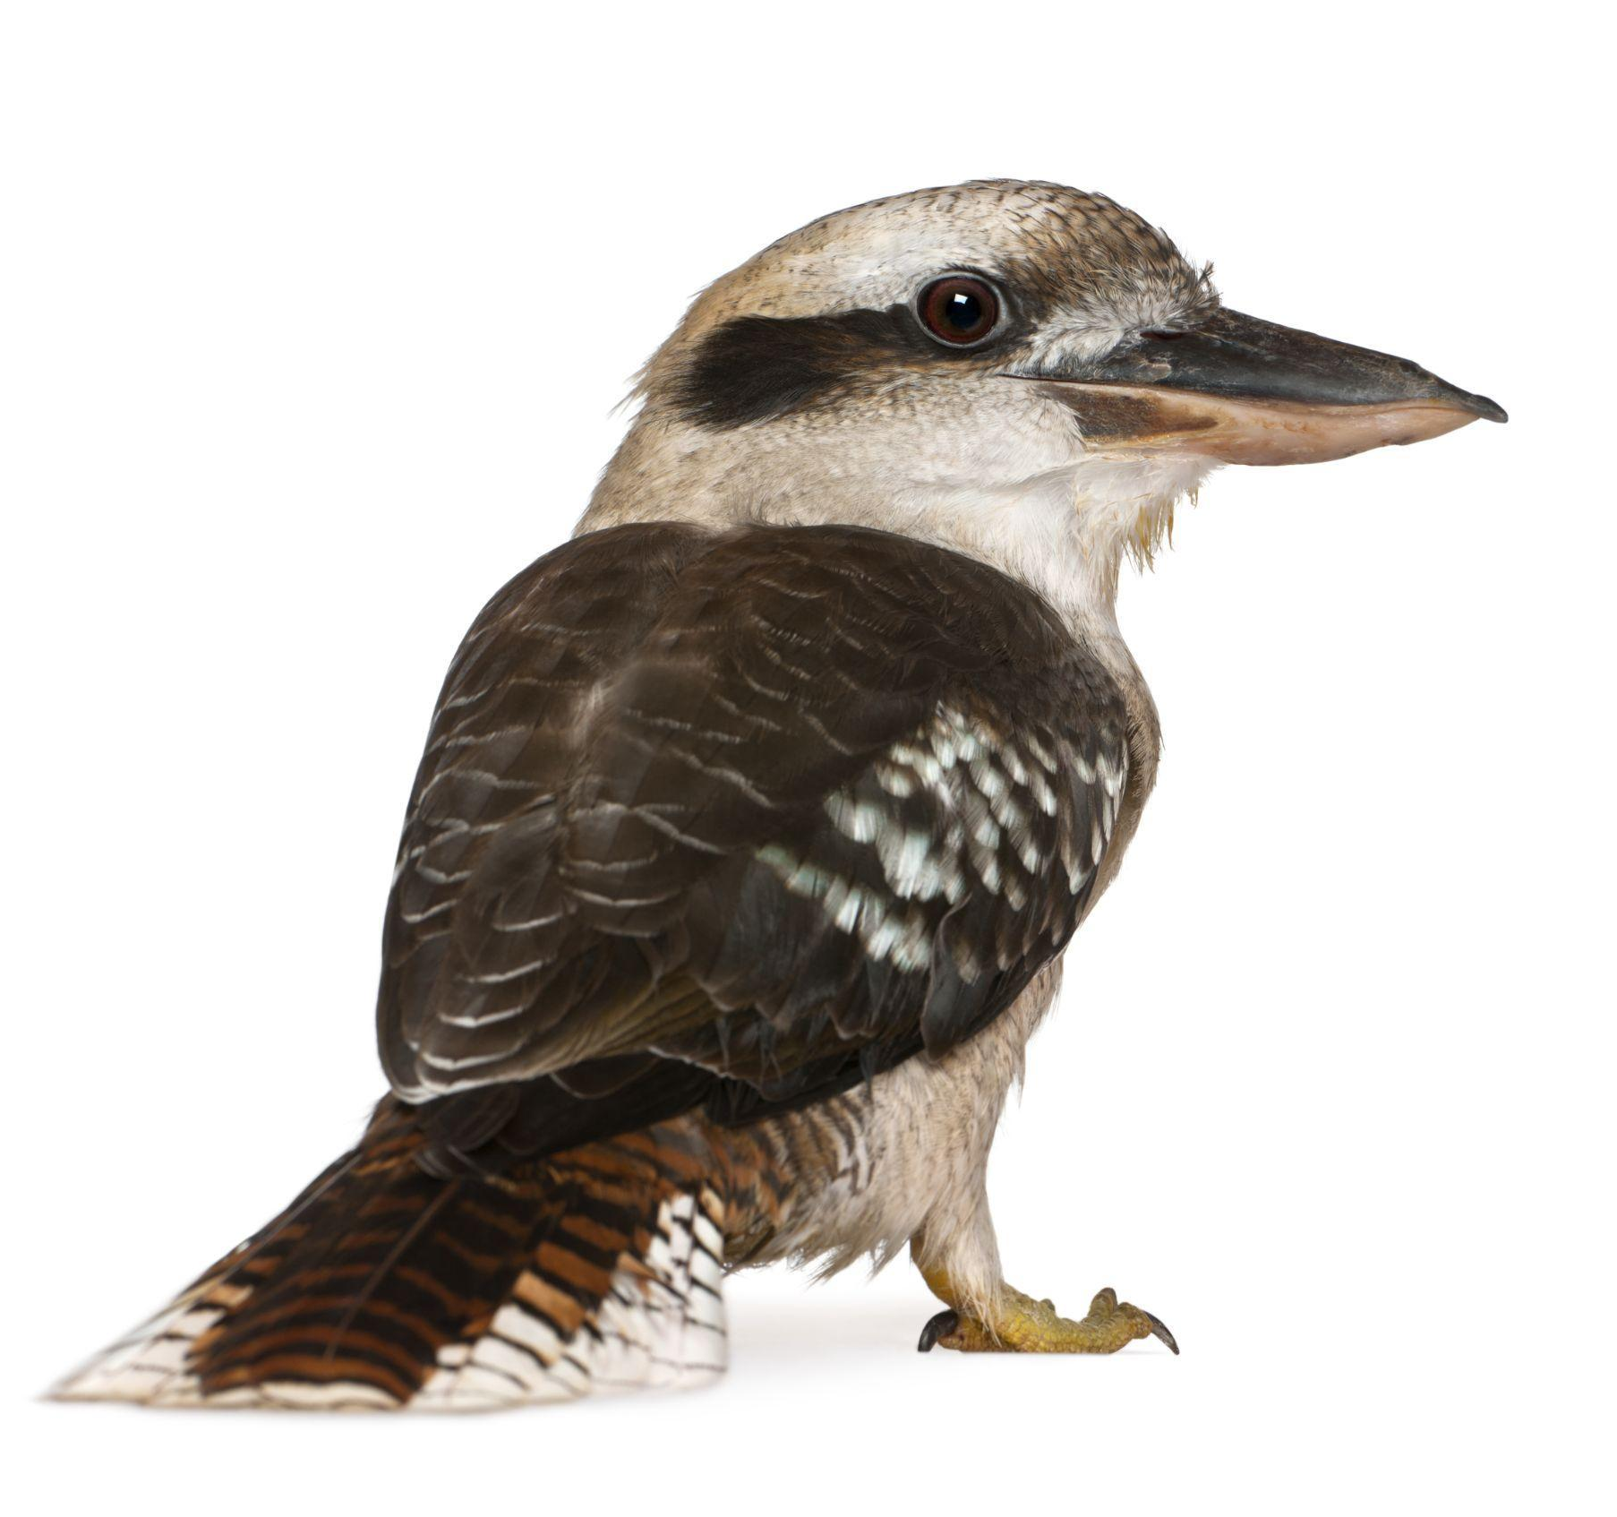
What animal am I?
5. I have feathers.
4. I like to fly.
3. Sometimes I like to catch and eat snakes.
2. I love to laugh.
1. I am a … kookaburra!

What animal am I?
5. I have fur.
4. I like to dig in the dirt.
3. I have a big hairy nose.
2. I can run as fast as a human!
1. I am a … wombat!

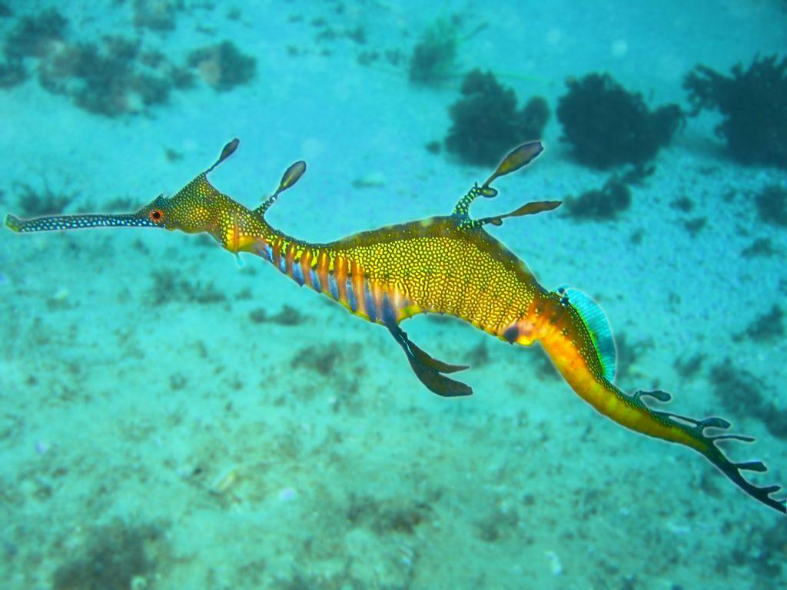
What animal am I?
5. I live in Port Phillip Bay.
4. I live in the water but I am not a good swimmer.
3. I like to eat tiny crabs.
2. I have leaf-like fins to hide in the seaweed.
1. I am a … weedy seadragon!

What animal am I?
5. I have scales.
4. I like to lie in the sun.
3. I am very poisonous.
2. I slither on the ground.
1. I am a … brown snake!

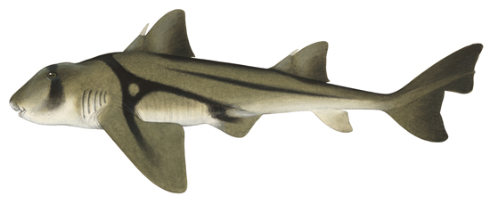What animal am I?
5. I have a long tail.
4. I like warmer water.
3. I am nocturnal (I am awake at night and sleep all day)
2. I like to eat shellfish.
1. I am a … Port Jackson Shark
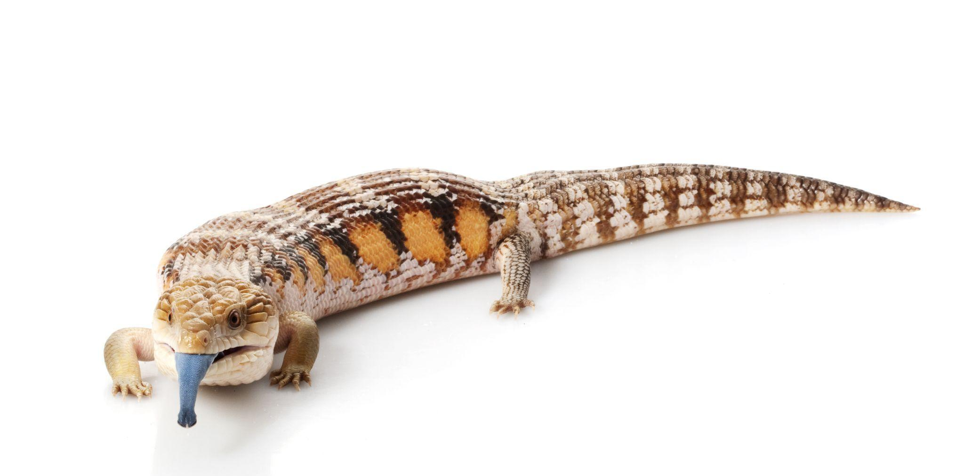
What animal am I?
5. I have scales.
4. I like to lie in the sun.
3. I like to poke out my tongue
2. My tongue is a surprising colour!
1. I am a … blue tongue lizard!

