Use the words at the bottom of the page to fill in the facts about each animal.
Students could cut out the words and paste them in the spaces, or rewrite them.
You can change any of the questions if they’re too tough for your students.
Answer pages have been included at the end of the document.
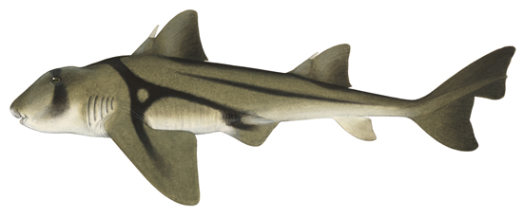
What do Port Jackson Sharks look like?
Port Jackson Sharks are ____________________ and ___________________ in colour.
Their colours and patterns are meant to look like _______________ on the bottom of the ocean. They have a flat ________________.
Where do Port Jackson Sharks live?
Port Jackson Sharks like to swim in ________________ that is ________________.
They are nocturnal which means they ________________ in the _______________ and are ________________ at ________________.
What do Port Jackson Sharks eat?
Port Jackson Sharks eat _________________ with their strong teeth.
What else?
Port Jackson Sharks lay eggs that have a _______________ shape.

spiral water head shellfish
warm light brown day time awake
dark brown sleep night rocks

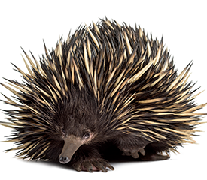
What do echidnas look like?
Echidnas are ________________ in colour.
Echidnas have long _________________.
Echidnas have sharp _________________ for digging.
Echidnas are covered in _________________.
Where do echidnas live?
Echidnas live in the _______________.
Echidnas dig _________________.
What do echidna’s eat?
Echidnas eat _________________.
Echidnas do not have any _________________.
What about baby echidnas?
Echidnas lay _________________.
Their babies drink _________________.

milk teeth beaks insects spines
brown burrows claws eggs bush
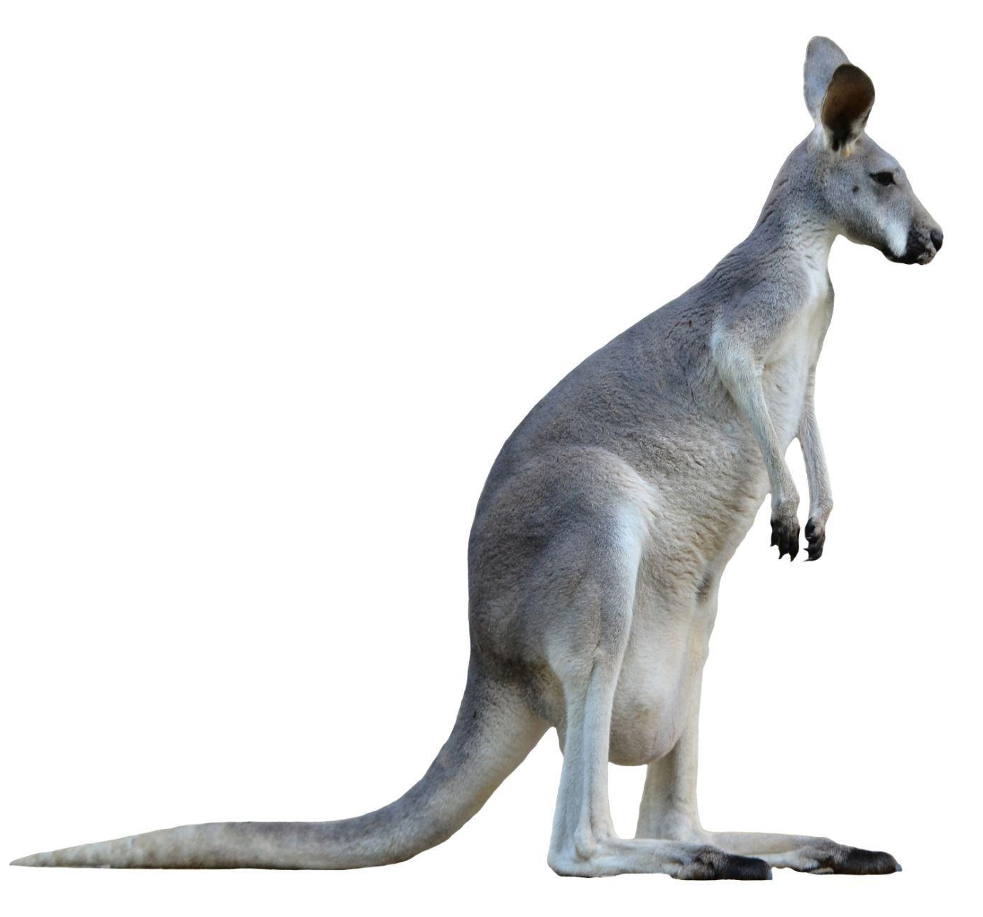
What do kangaroos look like?
Kangaroos are ________________ in colour.
Kangaroos have long _________ they use to __________.
They also have long _________________.
Kangaroos are covered in _________________.
Where do kangaroos live?
Kangaroos live in the ____________ and the _______________.
What do kangaroos eat?
Kangaroos eat _________________.
What about baby kangaroos?
Baby kangaroos are called _________________.
They live in their mum’s _________________.
They drink _________________.

grey grass fur joeys
milk legs grasslands pouch tails jump bush
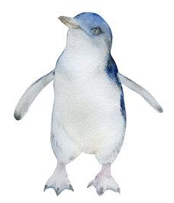
What do little penguins look like?
Little penguins are ________________ and ________________ in colour.
Little penguins are covered
in ________________.
Little penguins have ________________ feet like flippers for _________________.
Where do little penguins live?
Little penguins live on _____________ and at ________________.
What do little penguins eat?
Little penguins eat small ____________ and shrimp.
What else?
Little penguins hatch from _________________.
Little penguins are water _________________.

white webbed fish St Kilda
eggs Phillip Island swimming blue-grey
birds feathers

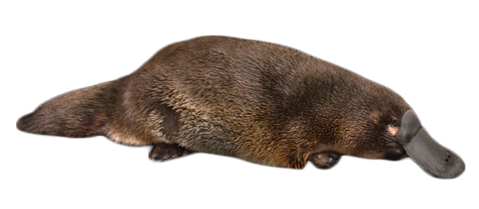
What do platypus look like?
Platypus are ________________ in colour.
They have _________________ like a ________________.
They have _________________ for _________________.
Platypus are covered in _________________.
Where do platypus live?
Platypus live in ______________ or ________________.
At night they sleep in ________________.
What do platypus eat?
Platypus eats _________________.
What about baby platypus?
Platypus lay _________________.
Their babies drink _________________.

beaks burrows fur eggs
insects swimming brown creeks
webbed feet billabongs milk duck

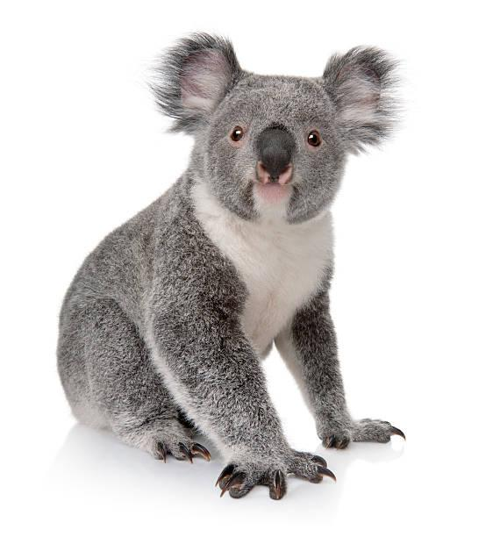
What do koalas look like?
Koalas have big ________________.
They have sharp ________________.
Where do koalas live?
If you look up, you might see a koala in a _____________.
Koalas spend up to 20 hours a day ______________!
What do koalas eat?
Koalas eat _________________.
These are actually very _____________, but not for koalas.
What about baby koalas?
Baby koalas are called _________________.
They live in their mum’s _________________ until they are a bit older. Then they ride on their mum’s ______________.
They drink _________________.

pouch gumtree sleeping joeys ears poisonous claws gum leaves milk back

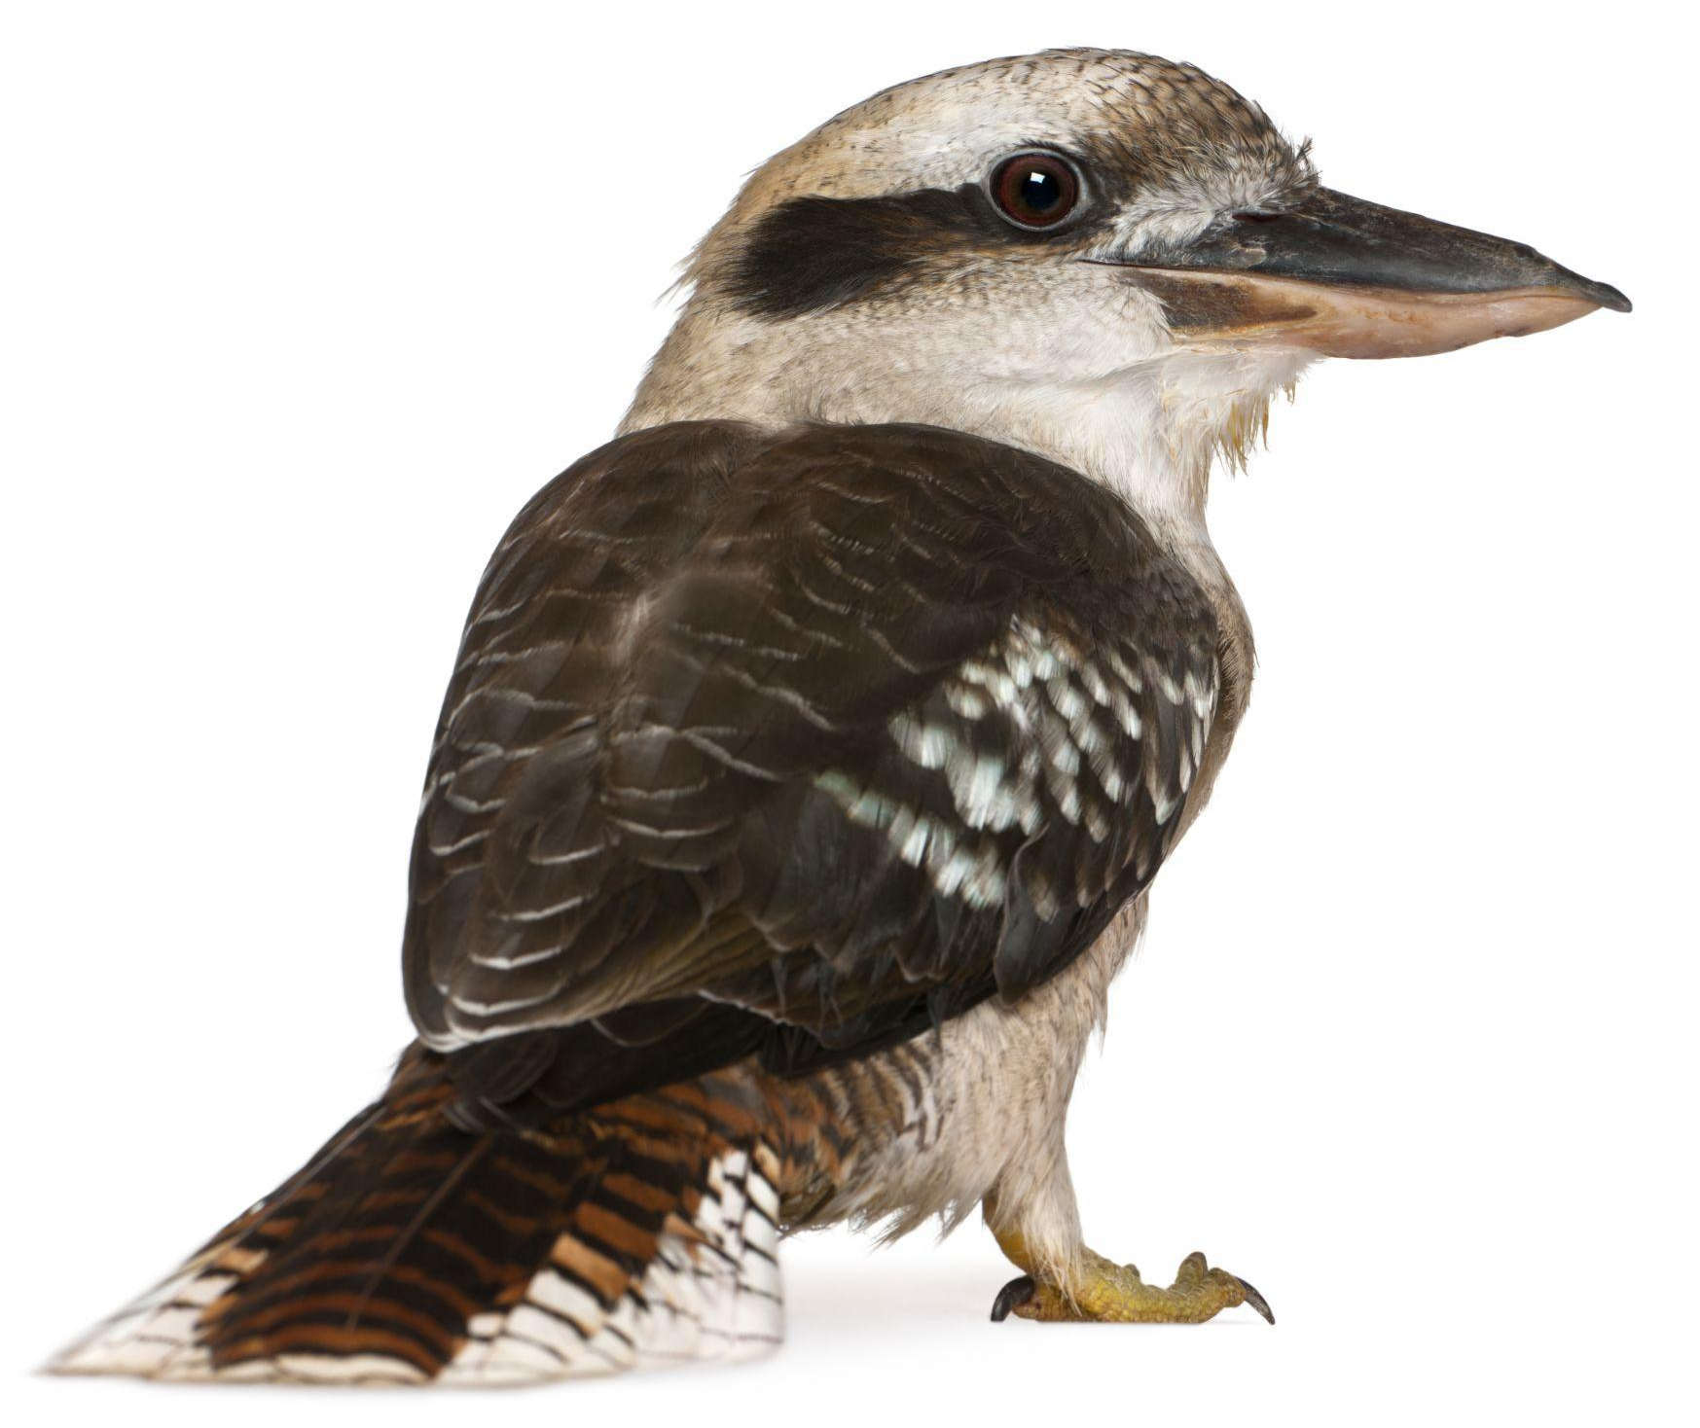
What do kookaburras look like?
Kookaburras have big ________________.
They are covered in ________________ that are the colours ________________, ________________ and sometimes ________________.
Where do kookaburras live?
Kookaburras build their _____________ in a hole in a _____________.
What do kookaburras eat?
Kookaburras actually love to eat _________________.
They eat _________________ and sometimes catch and eat small _________________.
What else?
Kookaburras love to _________________.

meat brown snakes white
nests beaks insects laugh
feathers gumtree blue
What do wombats look like?
Wombats have big ________________ ears and noses.
They are covered in ________________ that is the colour ________________. They have sharp ________________ for ________________.
Where do wombats live?
Wombats dig their _____________ deep in the ground.
What do wombats eat?
Wombats love to eat _________________. Their _________________ never stop growing!
What else?
Wombats can _________________ as fast as a _________________!

human brown run digging
fur hairy teeth claws
burrows grass

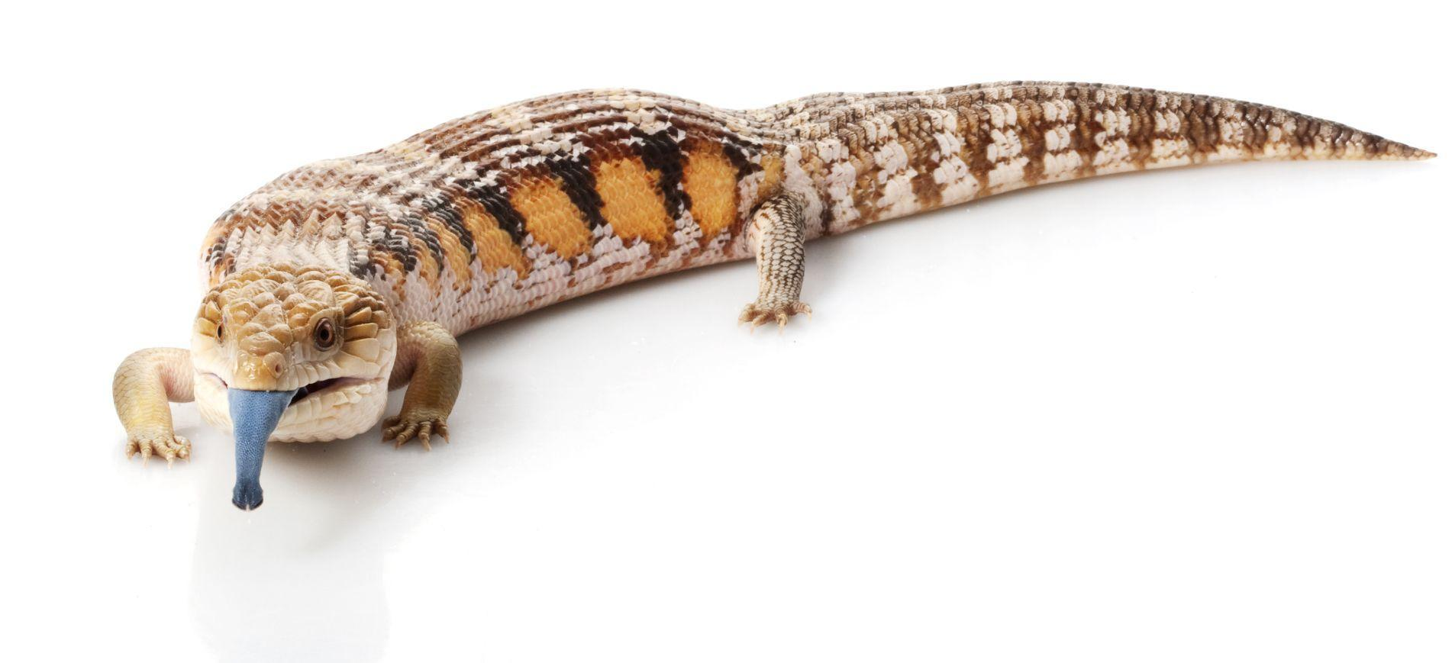
What do blue-tongued lizards look like?
Blue-tongued lizards are covered in ____________.
They have sharp ________________. They have a long ________________. Of course, they are best known for their ________________ which is the colour ________________!
Where do blue-tongued lizards live?
Blue-tongued lizards hide under _____________ or in _____________ on the ground. In the morning they will warm up by sitting on a _____________ in the _____________.
What do blue-tongued lizards eat?
Blue-tongued lizards love to eat _________________.
What else?
As blue-tongued lizards grow _________________ they shed their _________________ just like _________________.

tail skin blue leaves
bigger scales insects rock logs
snakes claws tongue sun
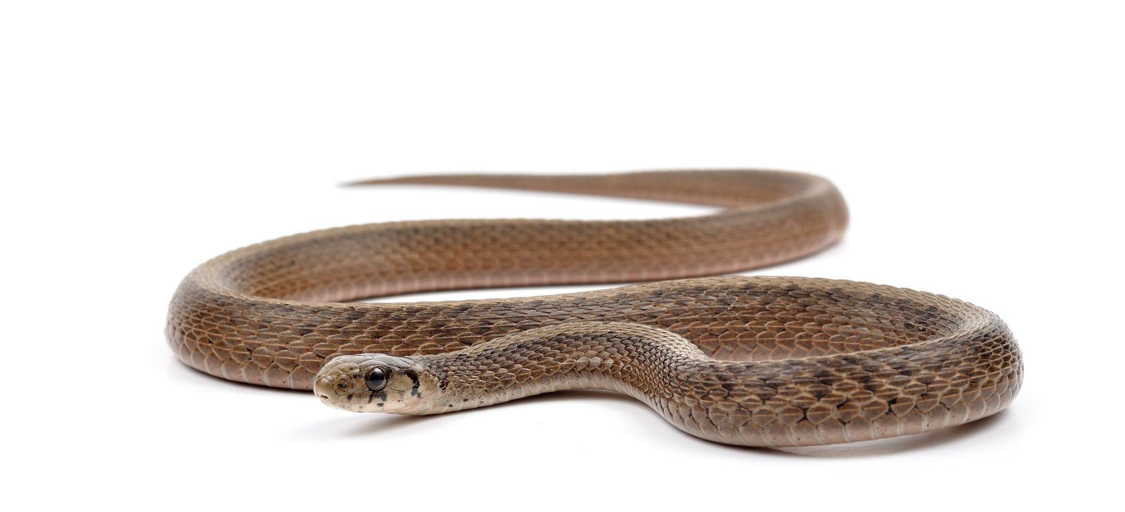
What do brown snakes look like?
Brown snakes are covered in ____________.
They have two sharp ________________ (teeth) and a long ________________. They don’t have any ________________.
Where do brown snakes live?
Brown snakes usually hide in long _____________ but you can see them warming up in the _____________ in the morning.
What do brown snakes eat?
Brown snakes love to eat _________________ and sometimes _________________.
What else?
Be very careful if you see a brown snake. They are very _________________. If you are bitten by a brown snake you must go to the _________________ very quickly.

fangs mice frogs sun
grass scales venomous hospital legs tongue
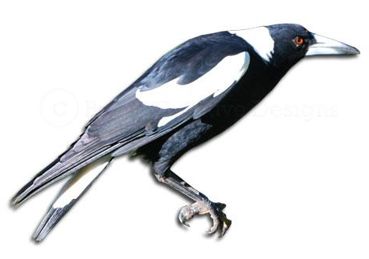
What do magpies look like?
Magpies are covered in ____________.
They have a sharp ________________. They are ________________ and ________________ in colour.
Where do magpies live?
Magpies build their _____________ in _____________.
You will know where they live because they will _____________ you to protect their _____________!
What do magpies eat?
Magpies eat all kinds of _________________.
What else?
Magpies are very _________________. They can remember your _________________. So make sure you are _________________ to magpies!

white eggs meat face nice
nests swoop feathers trees
black smart beak
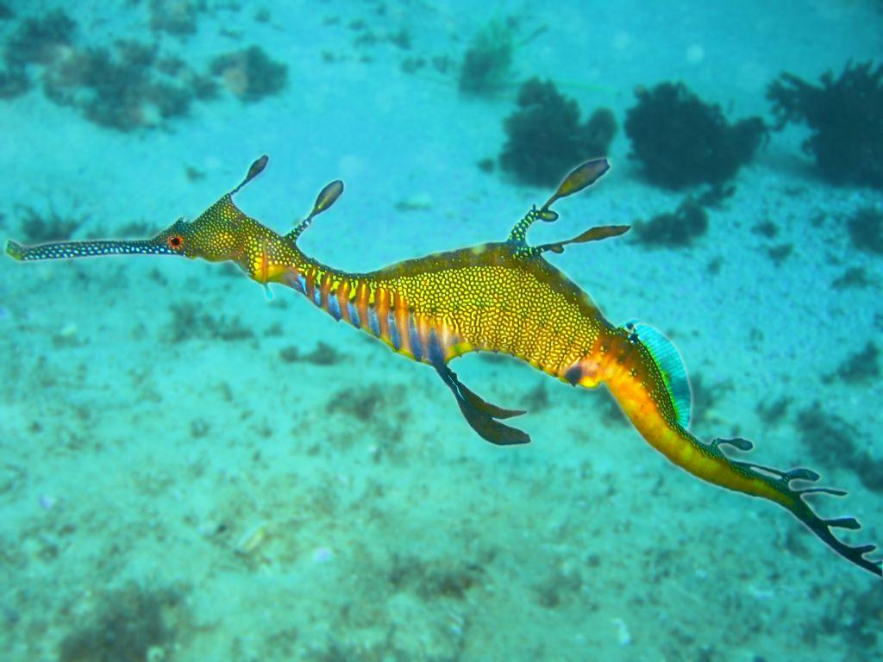
What do weedy seadragons look like?
Weedy seadragons look like they have ____________ growing out of their ____________. This helps them ____________ in ____________.
Where do weedy seadragons live?
If you go down to ____________________________________, you might see a weedy seadragon in the ____________.
What do weedy seadragons eat?
Weedy seadragons love to eat tiny _________________.
What else?
Weedy seadragons are actually not very good at _______________ because their fins are very _______________.
It is the _________________ seadragon that looks after the _________________ and the _______________ when they hatch.

leaves small male (dad) eggs
swimming hide backs babies
Port Phillip Bay crabs water seaweed
What do Port Jackson Sharks look like?
Port Jackson Sharks are
light brown _ and
dark brown _ in colour.
Their colours and patterns are meant to look like rocks _ on the bottom of the ocean. They have a flat head _.
Where do Port Jackson Sharks live?
Port Jackson Sharks like to swim in water _ that is
warm _.
They are nocturnal which means they sleep _ in the
day time _ and are awake _ at night _.
What do Port Jackson Sharks eat?
Port Jackson Sharks eat shellfish _ with their strong teeth.
What else?
Port Jackson Sharks lay eggs that have a _____spiral_______ shape.

spiral water head shellfish
warm light brown day time awake
dark brown sleep night rocks
What do echidnas look like?
Echidnas are brown _
in colour.
Echidnas have long
beaks _.
Echidnas have sharp
claws _ for digging.
Echidnas are covered in spines _.
Where do echidnas live?
Echidnas live in the bush _.
Echidnas dig burrows _.
What do echidna’s eat?
Echidnas eat insects _.
Echidnas do not have any teeth _.
What about baby echidnas?
Echidnas lay eggs _.
Their babies drink milk _.

milk teeth beaks insects spines
brown burrows claws eggs bush
What do kangaroos look like?
Kangaroos are grey _
in colour.
Kangaroos have long legs _ they use to jump _.
They also have long
tails _.
Kangaroos are covered in fur _.
Where do kangaroos live?
Kangaroos live in the bush and in grasslands _.
What do kangaroos eat?
Kangaroos eat grass _.
What about baby kangaroos?
Baby kangaroos are called joeys _.
They live in their mum’s pouch _.
They drink milk _.

grey grass fur joeys
milk legs grasslands pouch tails jump bush
What do little penguins look like?
Little penguins are white _
and blue-grey _ in colour.
Little penguins are covered
in feathers _.
Little penguins have webbed _ feet like flippers for swimming _.
Where do little penguins live?
Little penguins live on Phillip Island _ and at __St Kilda_ _.
What do little penguins eat?
Little penguins eat small fish _ and shrimp.
What else?
Little penguins hatch from eggs _.
Little penguins are water ____birds_______.

white webbed fish St Kilda
eggs Phillip Island swimming blue-grey
brids feathers
What do platypus look like?
Platypus are brown _
in colour.
They have beaks _
like a duck _.
They have webbed feet _ for swimming _.
Platypus are covered in fur _.
Where do platypus live?
Platypus live in creeks _ or billabongs _.
At night they sleep in burrows _.
What do platypus eat?
Platypus eats insects _.
What about baby platypus?
Platypus lay eggs _.
Their babies drink milk _.

beaks burrows fur eggs
insects swimming brown creeks
webbed feet billabongs milk duck

What do koalas look like?
Koalas have big ears _.
They have sharp claws _.
Where do koalas live?
If you look up, you might see a koala in a gumtree _.
Koalas spend up to 20 hours a day sleeping _!
What do koalas eat?
Koalas eat gum leaves _.
These are actually very poisonous _, but not for koalas.
What about baby koalas?
Baby koalas are called joeys _.
They live in their mum’s pouch _ until they are a bit older. Then they ride on their mum’s back _.
They drink milk _.

pouch gumtree sleeping joeys ears poisonous claws gum leaves milk back

What do kookaburras look like?
Kookaburras have big
beaks _.
They are covered in
feathers _ that are the colours
brown _, white _ and sometimes blue _.
Where do kookaburras live?
Kookaburras build their nests _ in a hole in a
gumtree _.
What do kookaburras eat?
Kookaburras actually love to eat meat _.
They eat insects _ and sometimes catch and eat small
snakes _.
What else?
Kookaburras love to laugh _.

meat brown snakes white
nests beaks insects laugh
feathers gumtree blue
What do wombats look like?
Wombats have big
hairy _ ears and noses.
They are covered in
fur _ that is the colour brown _ . They have sharp claws _ for digging _ .
Where do wombats live?
Wombats dig their burrows _ deep in the ground.
What do wombats eat?
Wombats love to eat grass _ . Their
teeth _ never stop growing!
What else?
Wombats can run _ as fast as a
human _ !

human brown run digging
fur hairy teeth claws
burrows grass
What do blue-tongued lizards look like?
Blue-tongued lizards are covered in scales _ .
They have sharp claws _ . They have a long
tail _ . Of course, they are best known for their
tongue _ which is the colour blue _ !
Where do blue-tongued lizards live?
Blue-tongued lizards hide under leaves _ or in
logs _ on the ground. In the morning they will warm up by sitting on a rock _ in the sun _ .
What do blue-tongued lizards eat?
Blue-tongued lizards love to eat insects _ .
What else?
As blue-tongued lizards grow bigger _ they shed their
skin _ just like snakes _ .

tail skin blue leaves
bigger scales insects rock logs
snakes claws tongue sun
What do brown snakes look like?
Brown snakes are covered in scales _ .
They have two sharp fangs _ (teeth) and a long
tongue _ . They don’t have any legs _ .
Where do brown snakes live?
Brown snakes usually hide in long grass _ but you can see them warming up in the sun _ in the morning.
What do brown snakes eat?
Brown snakes love to eat mice _ and sometimes
frogs _ .
What else?
Be very careful if you see a brown snake. They are very
venomous _. If you are bitten by a brown snake you must go to the hospital _ very quickly.

fangs mice blue
grass scales venomous frogs
hospital legs tongue sun
What do magpies look like?
Magpies are covered in
feathers _.
They have a sharp
beak _. They are
black _ and white _ in colour.
Where do magpies live?
Magpies build their nests _ in trees _.
You will know where they live because they will swoop _ you to protect their eggs _!
What do magpies eat?
Magpies eat all kinds of meat _.
What else?
Magpies are very smart _. They can remember your
face _. So make sure you are nice _ to magpies!

white eggs meat face nice
nests swoop feathers trees
black smart beak
What do weedy seadragons look like?
Weedy seadragons look like they have leaves _ growing out of their backs _. This helps them hide _ in seaweed _.
Where do weedy seadragons live?
If you go down to Port Phillip Bay _, you might see a weedy seadragon in the water _.
What do weedy seadragons eat?
Weedy seadragons love to eat tiny crabs _.
What else?
Weedy seadragons are actually not very good at swimming _ because their fins are very small _.
It is the male (dad) _ seadragon that looks after the
eggs _ and the babies _ when they hatch.

leaves small male (dad) eggs
swimming hide backs babies
Port Phillip Bay crabs water seaweed

